PowerShell + SQL Server — Skills-Based Assessment

Part 1: Running the Assessment
Walk through each task in order, running the corresponding script and confirming the output. Run everything from the project root folder.

Task 1 — Connect to SQL Server
Create connection.ps1. Open a connection to the local SQL Server instance using Windows authentication, confirm success, then close it cleanly.
$connectionString = "Server=localhost;Database=master;Trusted_Connection=True;"
$connection = New-Object System.Data.SqlClient.SqlConnection
$connection.ConnectionString = $connectionString
try {
$connection.Open()
Write-Host "Connection to the SQL Server established successfully!" -ForegroundColor Green
} catch {
Write-Host "Connection failed: $_" -ForegroundColor Red
} finally {
if ($connection.State -eq 'Open') {
$connection.Close()
Write-Host "Connection closed." -ForegroundColor Yellow
}
}
Expected console output: Connection to the SQL Server established successfully! Connection closed.
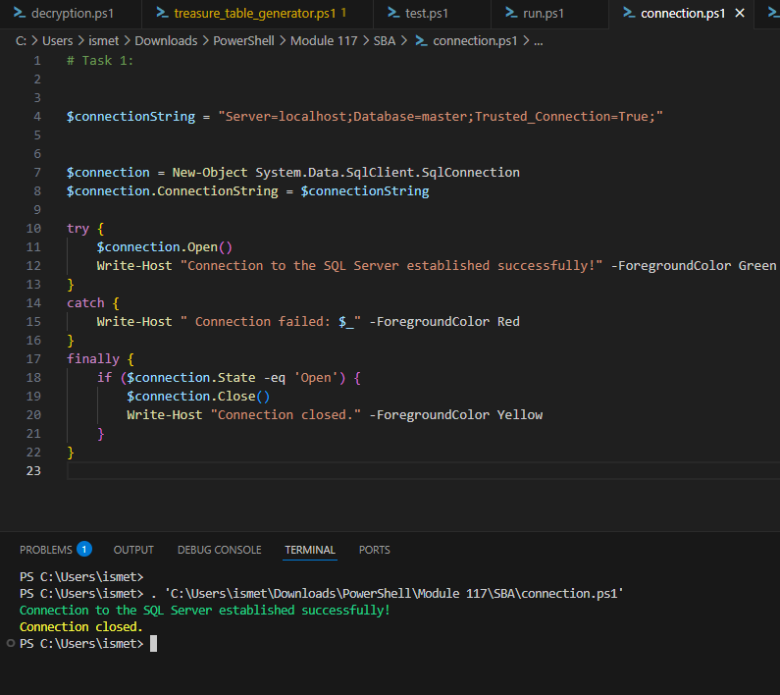
connection.ps1 run successfully — connection opened and closed cleanly.

Task 2 — Query and Display Adventurer Names
Query the Adventurers table and display each name in a scroll-like list.
$query = "SELECT Name FROM Adventurers"
$command = $connection.CreateCommand()
$command.CommandText = $query
$adapter = New-Object System.Data.SqlClient.SqlDataAdapter $command
$dataset = New-Object System.Data.DataSet
$adapter.Fill($dataset) | Out-Null
Write-Host "Adventurers :" -ForegroundColor Cyan
$dataset.Tables[0] | ForEach-Object {
Write-Host " - $($_.Name)" -ForegroundColor Yellow
}
Expected: a list of 20 adventurer names printed under the "Adventurers :" header.
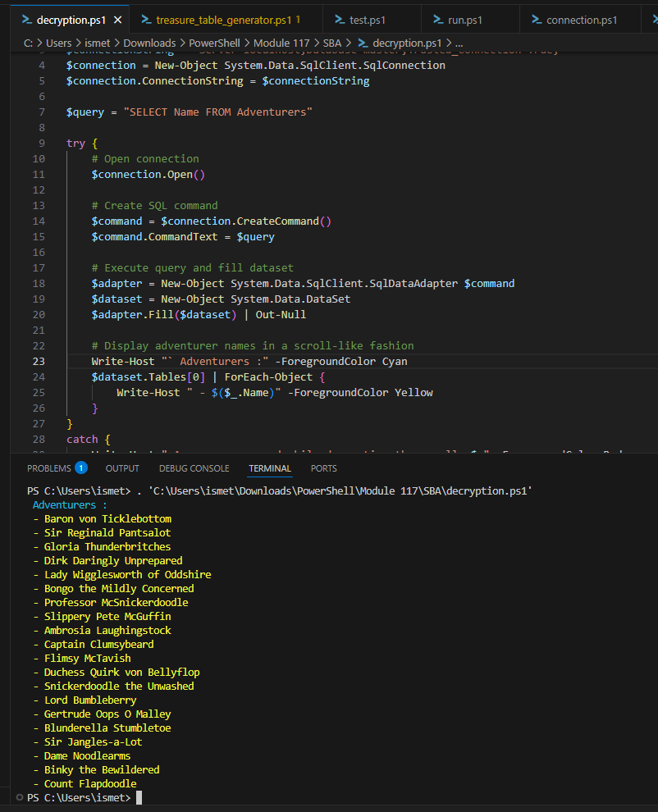
Query run successfully, listing all 20 adventurer names from the Adventurers table.

Task 3 — Create and Populate the Adventurers Table
Create task3-InsertValue.ps1. Drop and recreate the Adventurers table, then insert 20 sample adventurer names.
$createAdventurersTable = "
DROP TABLE IF EXISTS Adventurers
CREATE TABLE Adventurers (
Id INT IDENTITY(1,1) PRIMARY KEY,
Name NVARCHAR(100) NOT NULL
);
"
$adventurersValues = "
INSERT INTO Adventurers (Name) VALUES
('Baron von Ticklebottom'),
('Sir Reginald Pantsalot'),
('Gloria Thunderbritches'),
-- ... 17 more sample names ...
"
Expected console output: Inserted 20 sample records into Adventurers table, followed by a numbered list of Id/Name pairs.
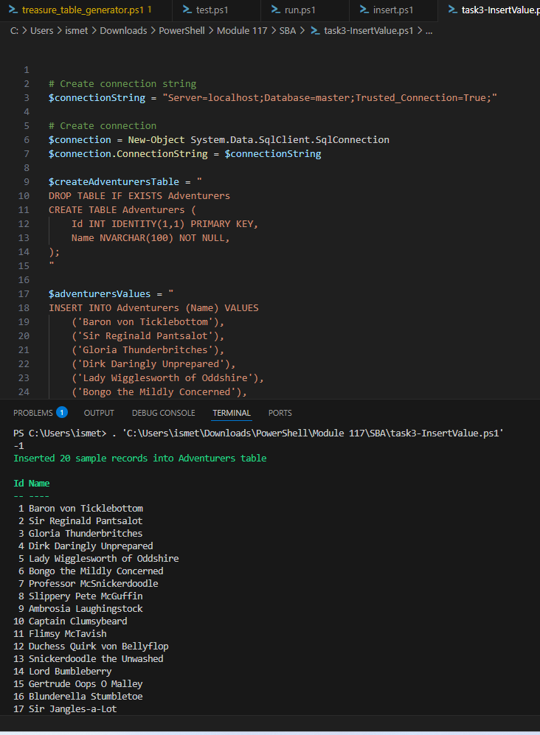
task3-InsertValue.ps1 run successfully — 20 adventurer records created and listed.

Task 4 — Create and Populate the LostArtifacts Table
Create Task4-ArtifactsTable.ps1. Drop and recreate a LostArtifacts table with a status check constraint, then insert 20 sample artifacts with alternating Lost/Restored statuses.
$createLostArtifactsTable = "
DROP TABLE IF EXISTS LostArtifacts
CREATE TABLE LostArtifacts (
ArtifactId INT IDENTITY(1,1) PRIMARY KEY,
ArtifactName NVARCHAR(100) NOT NULL,
ArtifactPower NVARCHAR(100) NOT NULL,
ArtifactStatus NVARCHAR(100) CHECK (ArtifactStatus IN ('Lost', 'Restored'))
);
"
Expected console output: Inserted 20 sample records into Lost Artifacts table, followed by a table of ArtifactId, ArtifactName, ArtifactPower, and ArtifactStatus columns.
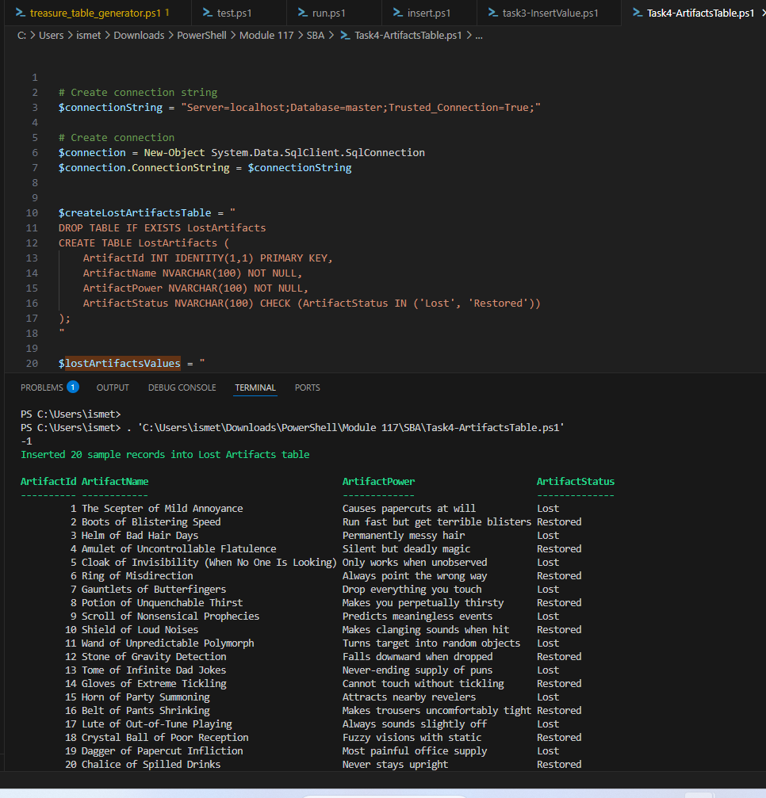
Task4-ArtifactsTable.ps1 run successfully — 20 artifact records created with alternating Lost/Restored status.

Task 4b — Filter to Show Only Lost Artifacts
Query the LostArtifacts table filtered to ArtifactStatus = 'Lost', to confirm the starting state before restoration.
$lostOnlyQuery = "SELECT * FROM LostArtifacts WHERE ArtifactStatus = 'Lost'"
Expected: a table listing only the artifacts currently marked Lost.
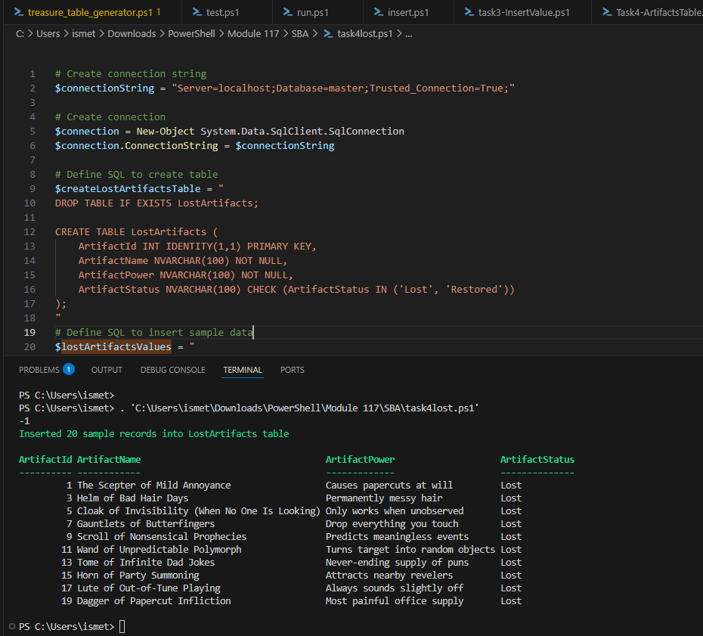
Filtered query showing only artifacts with ArtifactStatus = 'Lost' before restoration.

Task 5 — Restore All Lost Artifacts
Create Task5.ps1. Update every Lost artifact to Restored, then verify by querying for all Restored rows.
$restoreLostArtifacts = "
UPDATE LostArtifacts
SET ArtifactStatus = 'Restored'
WHERE ArtifactStatus = 'Lost';
"
$verifyRestoration = "
SELECT * FROM LostArtifacts WHERE ArtifactStatus = 'Restored';
"
Expected console output: "All Restored Artifacts:" followed by a table where every row's ArtifactStatus column reads Restored.
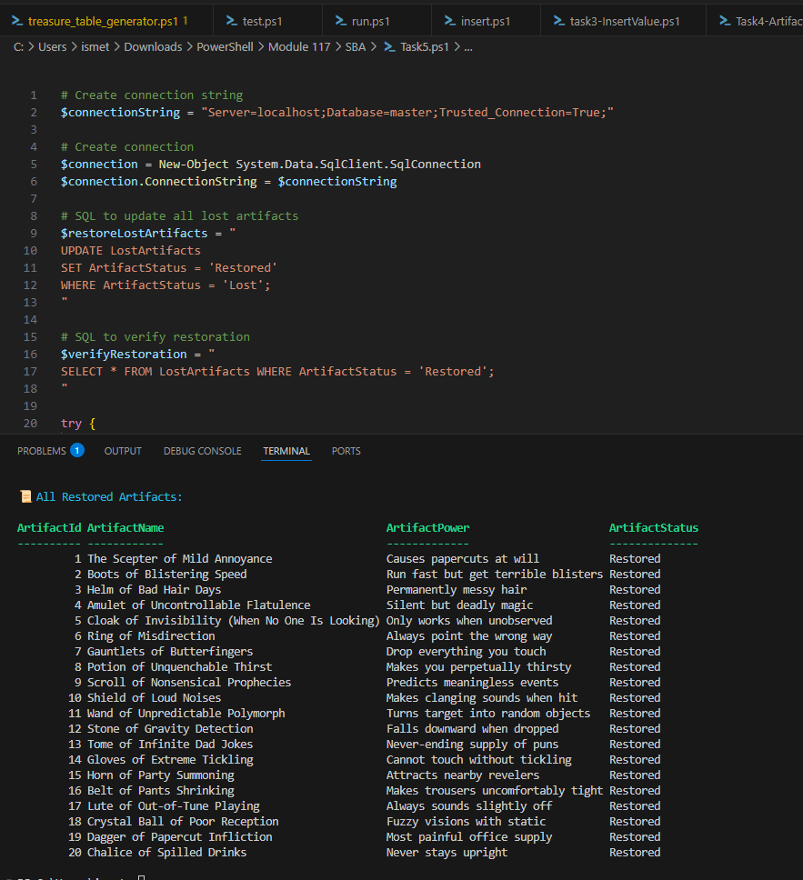
Task5.ps1 run successfully — all 20 artifacts now show ArtifactStatus = Restored.

